Normalement le samedi……

1. [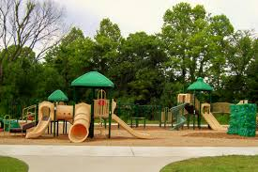](http://www.google.co.uk/url?sa=i&rct=j&q=&esrc=s&source=images&cd=&cad=rja&uact=8&ved=0CAcQjRxqFQoTCKepofauj8YCFYZYFAodms8AtQ&url=http://brentwood.thefuntimesguide.com/2007/07/new_brentwood_park_owlcreek.php&ei=0ot9Vaf4LIaxUZqfg6gL&bvm=bv.95515949,d.d24&psig=AFQjCNEmrdFaxwS2gQAA309TC9Ki5ixxnQ&ust=1434377541029674)

[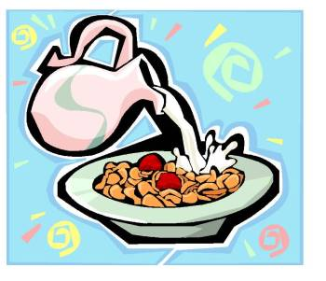](http://www.google.co.uk/url?sa=i&rct=j&q=&esrc=s&source=images&cd=&cad=rja&uact=8&ved=0CAcQjRxqFQoTCKKx46quj8YCFQM-FAodl6YA7A&url=http%3A%2F%2Fwww.body-wise-perfect-size.com%2Fbreakfast-buzz.html&ei=NIt9VaLHGoP8UJfNguAO&bvm=bv.95515949,d.d24&psig=AFQjCNHkYnnM9YdNY74OG5IYeg2VnjeoVA&ust=1434377380651506)

[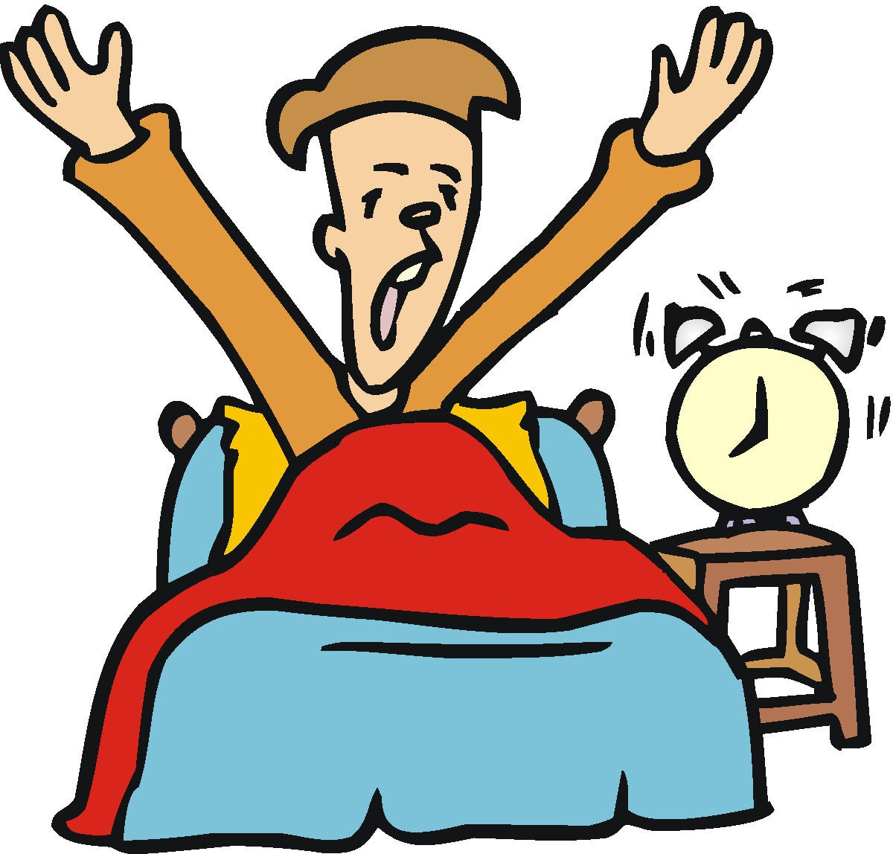](http://www.google.co.uk/url?sa=i&rct=j&q=&esrc=s&source=images&cd=&cad=rja&uact=8&ved=0CAcQjRxqFQoTCLW9yMWtj8YCFcjJFAodPXoAfA&url=http%3A%2F%2Fwww.fredericpatenaude.com%2FLessSleepMoreEnergy.html&ei=YIp9VbWNC8iTU730geAH&bvm=bv.95515949,d.d24&psig=AFQjCNHGEjoi_GvzumFeRT421t9j-BXs3A&ust=1434377179286259)

We are going to go to the cinema

+ opinion

Go back home by foot

We eat in a café. Usually I eat….and I drink…..

[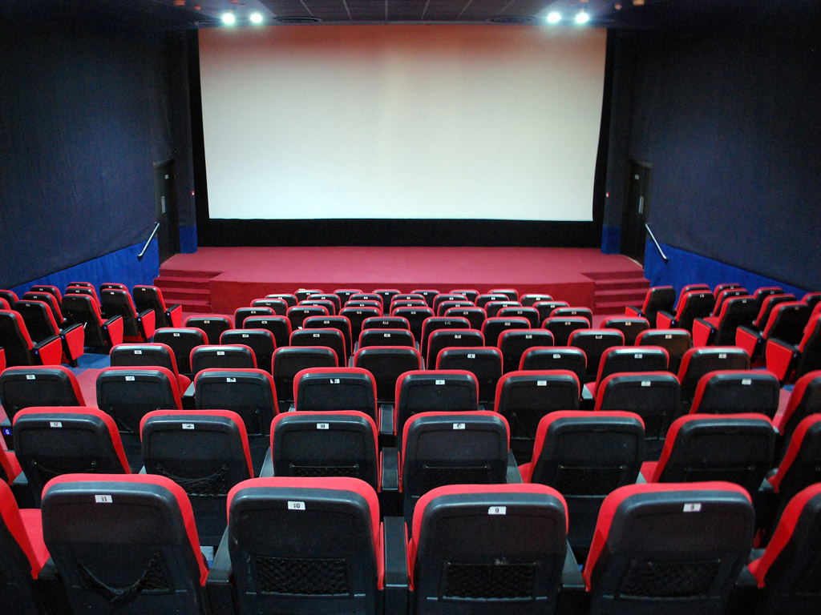](http://www.google.co.uk/url?sa=i&rct=j&q=&esrc=s&source=images&cd=&cad=rja&uact=8&ved=0CAcQjRxqFQoTCPXMkbuyj8YCFcu-FAod6asAsA&url=http://blogs.independent.co.uk/2013/04/04/don%E2%80%99t-let-the-rising-cost-of-popcorn-spoil-britain%E2%80%99s-love-of-cinema/&ei=iI99VfXoHcv9UunXgoAL&bvm=bv.95515949,d.d24&psig=AFQjCNGZVubnColQ6VLAFsD4l4SJyblQqw&ust=1434378491738044)

I am going to go into town with my family

[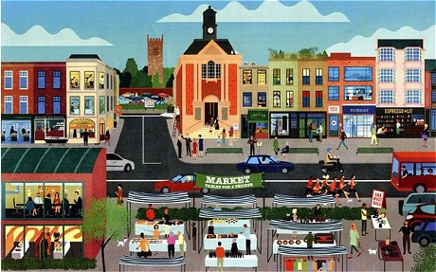](http://www.google.co.uk/url?sa=i&rct=j&q=&esrc=s&source=images&cd=&cad=rja&uact=8&ved=0CAcQjRxqFQoTCPWFmf-xj8YCFYZYFAodms8AtQ&url=http://www.telegraph.co.uk/finance/newsbysector/retailandconsumer/9686342/More-than-one-in-10-shops-standing-empty.html&ei=Co99VfXYL4axUZqfg6gL&bvm=bv.95515949,d.d24&psig=AFQjCNHjbuL1QpyXlRiR913sFw6UVETRYQ&ust=1434378355343827)

Le week-end prochain………

In the evening I watch TV with my family and listen to music

[](http://www.google.co.uk/url?sa=i&rct=j&q=&esrc=s&source=images&cd=&cad=rja&uact=8&ved=0CAcQjRxqFQoTCJWfpLixj8YCFUxdFAodvYIAyw&url=http%3A%2F%2Fwww.clipartpanda.com%2Fcategories%2Flisten-to-music-clipart&ei=do59VZWMBMy6Ub2FgtgM&bvm=bv.95515949,d.d24&psig=AFQjCNEmDG2R8UMmholLf0pvBRqWbsk5-w&ust=1434378219485618)

[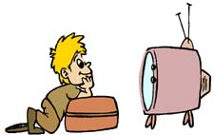](http://www.google.co.uk/url?sa=i&rct=j&q=&esrc=s&source=images&cd=&cad=rja&uact=8&ved=0CAcQjRxqFQoTCMbQ-Imxj8YCFQZxFAodzK0AOg&url=http%3A%2F%2Fblogs.babycenter.com%2Fmom_stories%2F10-19-2011-screw-the-new-tv-rules-parenting-fail%2F&ei=FI59Vcb2NYbiUczbgtAD&bvm=bv.95515949,d.d24&psig=AFQjCNEBg99onR8aWngmaBlPjPX-F2GLvg&ust=1434378115265444)

[](http://www.google.co.uk/url?sa=i&rct=j&q=&esrc=s&source=images&cd=&cad=rja&uact=8&ved=0CAcQjRxqFQoTCIvN-cywj8YCFYVZFAod03IAkQ&url=http%3A%2F%2Fwww.clipartpanda.com%2Fcategories%2Fclipart-house-images&ei=lI19VYuzO4WzUdPlgYgJ&bvm=bv.95515949,d.d24&psig=AFQjCNFM3rKEvi1JC1Tb7b-XmPJr_hhgYg&ust=1434377989926200)

[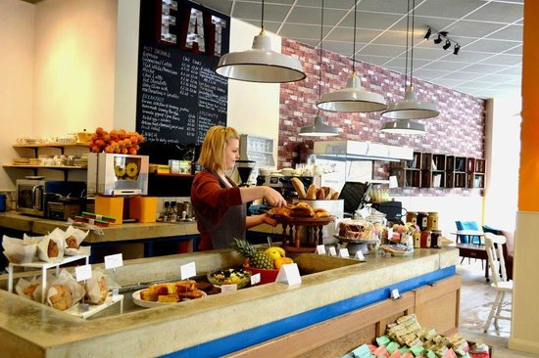](http://www.google.co.uk/url?sa=i&rct=j&q=&esrc=s&source=images&cd=&cad=rja&uact=8&ved=0CAcQjRxqFQoTCNL00Omvj8YCFUs8FAodnioA-g&url=http://www.tripadvisor.co.uk/LocationPhotoDirectLink-g186338-d3780815-i56128828-Eat_Play_Love-London_England.html&ei=xIx9VdKCKsv4UJ7VgNAP&bvm=bv.95515949,d.d24&psig=AFQjCNHP7mDz4HW8xtYfPHiBSVzWWnyUjQ&ust=1434377780177609)

We play football. I love football because……

1. [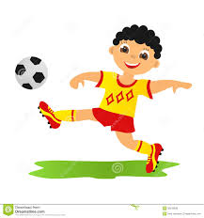](http://www.google.co.uk/url?sa=i&rct=j&q=&esrc=s&source=images&cd=&cad=rja&uact=8&ved=0CAcQjRxqFQoTCLu8i7ivj8YCFQvrFAod9xEA2w&url=http://galleryhip.com/little-kid-playing-football-cartoon.html&ei=XIx9VbueMIvWU_ejgNgN&bvm=bv.95515949,d.d24&psig=AFQjCNH6xFMfMmFm632Y4EzlVxV3iC9IgQ&ust=1434377670342336)

I go to the park with friends at 10.30

I have breakfast in the dining room with family

I wake up at 9 o’clock