Normalement, le dimanche…..

We are going to play tennis + opinion

Le week-end prochain….

1. [](http://www.google.co.uk/url?sa=i&rct=j&q=&esrc=s&source=images&cd=&cad=rja&uact=8&ved=&url=http%3A%2F%2Fclassified.haiwai.com%2Fclassified%2Findex.php%3Fc%3Ditems%26act%3Dview%26item_id%3D6792&ei=N-F9VfSOG8j3Uq2lg9AN&bvm=bv.95515949,d.d24&psig=AFQjCNG2MCPOe8gPHxxb8z2LG7WbHHnXcA&ust=1434399415835162)

I am going to go horse riding with my friends

1. [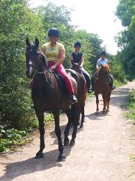](http://www.google.co.uk/url?sa=i&rct=j&q=&esrc=s&source=images&cd=&cad=rja&uact=8&ved=0CAcQjRxqFQoTCIXPleb_j8YCFUlZFAodJNYA-Q&url=http://www.stanwicklakes.org.uk/northampton/things-to-do/horse-riding/&ei=oOB9VYX_D8myUaSsg8gP&bvm=bv.95515949,d.d24&psig=AFQjCNH9L0wyp6-EQv9BCDQyg7g6Q5Oz3A&ust=1434399254397734)

In the evening I do my homework. + opinion

[](http://www.google.co.uk/url?sa=i&rct=j&q=&esrc=s&source=images&cd=&cad=rja&uact=8&ved=0CAcQjRxqFQoTCPfS59v-j8YCFUXvFAody7gA7Q&url=http%3A%2F%2Fpay-to-do-homework.essay4u.org%2Findex.html&ei=ft99VfebBsXeU8vxgugO&bvm=bv.95515949,d.d24&psig=AFQjCNGNT80I4ryM9fJbxpIZHAMP1oQq3w&ust=1434398968570146)

I go home

[](http://www.google.co.uk/url?sa=i&rct=j&q=&esrc=s&source=images&cd=&cad=rja&uact=8&ved=0CAcQjRxqFQoTCIvN-cywj8YCFYVZFAod03IAkQ&url=http://www.clipartpanda.com/categories/clipart-house-images&ei=lI19VYuzO4WzUdPlgYgJ&bvm=bv.95515949,d.d24&psig=AFQjCNFM3rKEvi1JC1Tb7b-XmPJr_hhgYg&ust=1434377989926200)

At 1 o’clock I eat lunch in a café. I eat….and I drink…..

[](http://www.google.co.uk/url?sa=i&rct=j&q=&esrc=s&source=images&cd=&cad=rja&uact=8&ved=0CAcQjRxqFQoTCMm_84T-j8YCFUEbFAodpBYABA&url=http://brecon.fyinetwork.co.uk/my,8972-tradesman-lunch-boxes&ei=x959VYnAM8G2UKStgCA&bvm=bv.95515949,d.d24&psig=AFQjCNFBsqQxayUhcljXKY420Uw6JKrGFQ&ust=1434398730399157)

I go to the shops with my family and we buy…..

[](http://www.google.co.uk/url?sa=i&rct=j&q=&esrc=s&source=images&cd=&cad=rja&uact=8&ved=0CAcQjRxqFQoTCLrn3679j8YCFQpcFAodyQwAfA&url=http://thelincolnite.co.uk/2013/05/lincoln-waterside-shopping-centre-revamp-approved/&ei=E959VfqRCoq4UcmZgOAH&bvm=bv.95515949,d.d24&psig=AFQjCNHkfS5SF0st004otdeqrYkJipOCxA&ust=1434398606003219)

I go for a swim. I love swimming because…..

1. [](http://www.google.co.uk/url?sa=i&rct=j&q=&esrc=s&source=images&cd=&cad=rja&uact=8&ved=0CAcQjRxqFQoTCKn10-r8j8YCFUGaFAodWlYA9g&url=http%3A%2F%2Fwww.payhembury.org.uk%2Fslade-barton-swimming-pool-2%2F&ei=hN19VamjFsG0UtqsgbAP&bvm=bv.95515949,d.d24&psig=AFQjCNEk48q3xDiRIfle3CjwgV3LClEdlg&ust=1434398421411548)

I have breakfast in the kitchen with my family

[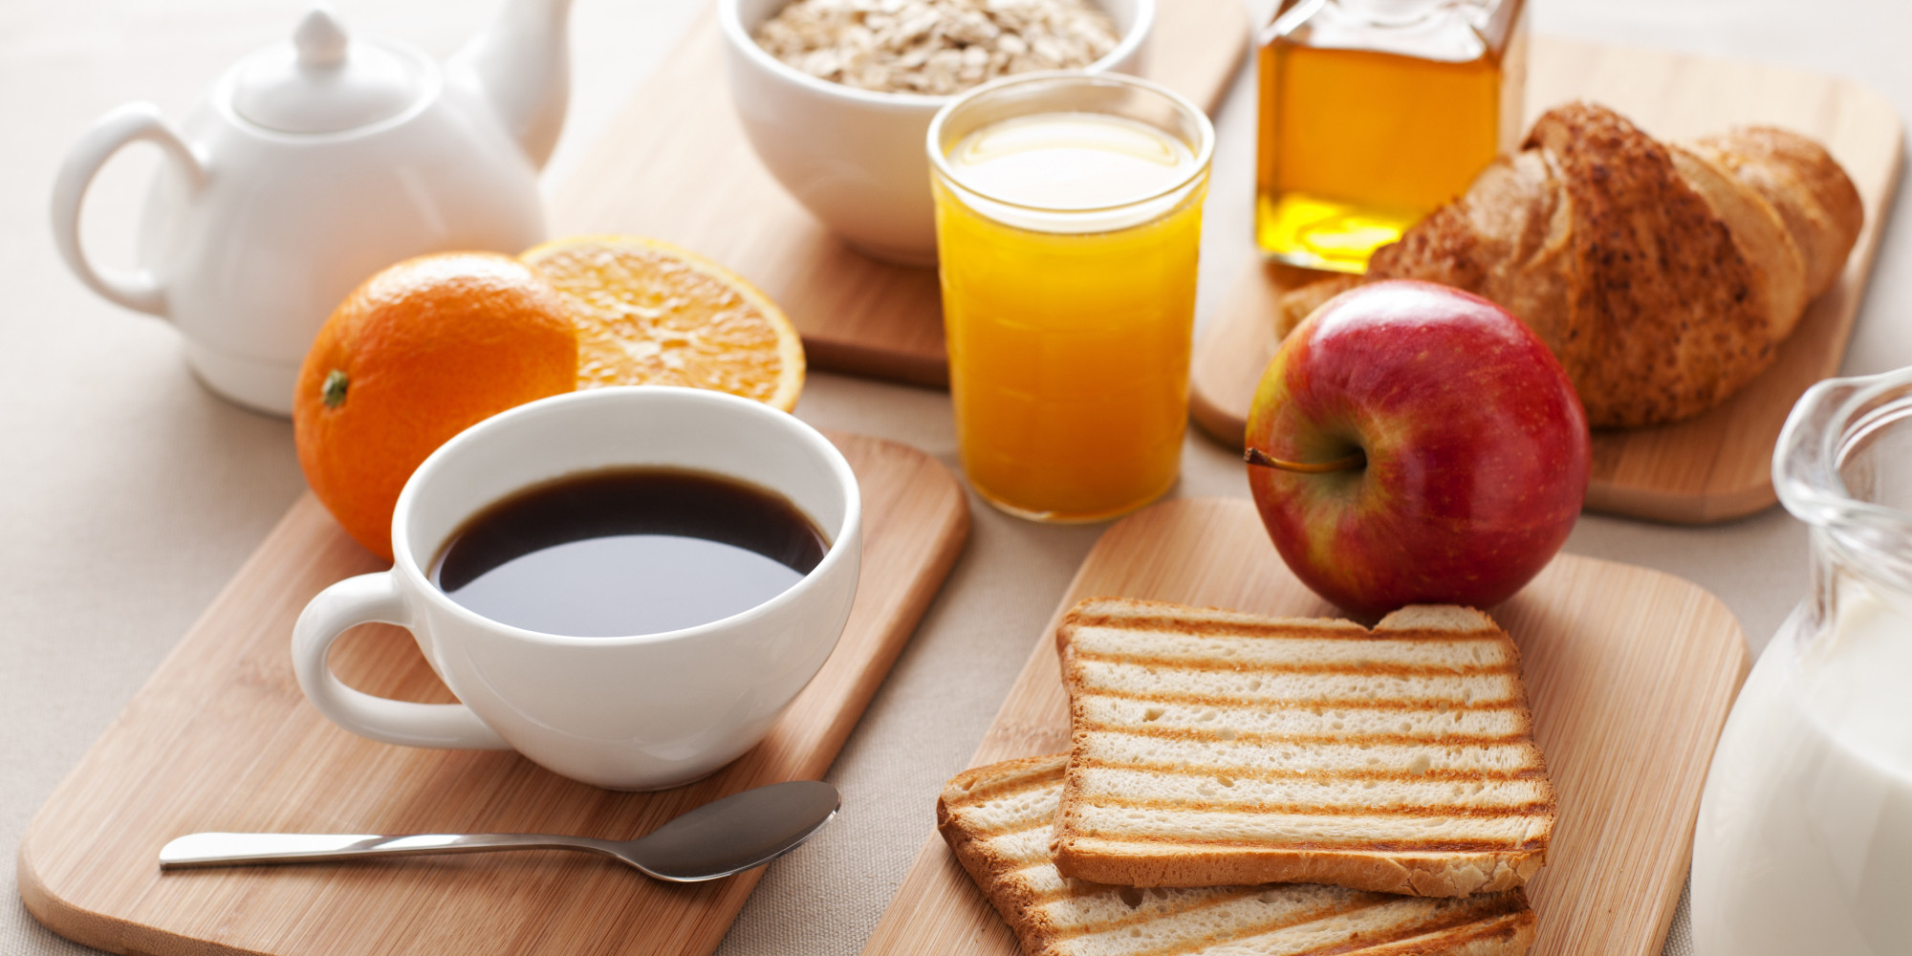](http://www.google.co.uk/url?sa=i&rct=j&q=&esrc=s&source=images&cd=&cad=rja&uact=8&ved=0CAcQjRxqFQoTCIyzpKb8j8YCFUrsFAodL2gA3w&url=http%3A%2F%2Fyourzonestudio.co.uk%2Fstopping-your-unhealthy-breakfast-addiction%2F&ei=9Nx9VYzpO8rYU6_QgfgN&bvm=bv.95515949,d.d24&psig=AFQjCNGoas7V70viSVS5hEsa29ZclsZLbg&ust=1434398306688947)

I wake up at 10 o’clock

[](http://www.google.co.uk/url?sa=i&rct=j&q=&esrc=s&source=images&cd=&cad=rja&uact=8&ved=0CAcQjRxqFQoTCLW9yMWtj8YCFcjJFAodPXoAfA&url=http://www.fredericpatenaude.com/LessSleepMoreEnergy.html&ei=YIp9VbWNC8iTU730geAH&bvm=bv.95515949,d.d24&psig=AFQjCNHGEjoi_GvzumFeRT421t9j-BXs3A&ust=1434377179286259)